[**How to Create a Password Protected Folder without any Extra Software**](http://www.howtogeek.com/105633/how-to-create-a-password-protected-folder-without-any-extra-software/)

  
There are a lot of methods that you can use to create a password protected folder, most of which require the use of some third party software. Using this neat method you can hide your folders with a quick batch script.

It’s important to note that this will not actually conceal your data from somebody who knows what they are doing.

*Note:***if you are a beginner you should not do this. We get emails once a week from people that don’t know what they are doing and complain they can’t find their files anymore. We also have instructions at the bottom for how to see the files again should you forget how to see them.**

**Create Your Password Protected Folder**

Before you get started you need to create a folder that will house your password protected folder, this is just an ordinary folder and can be located anywhere and named anything.

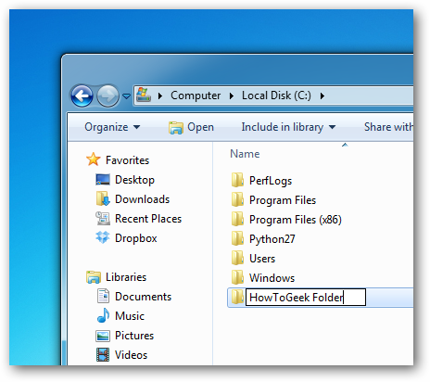

Navigate into your newly created folder and create a new Text Document. This can easily be done from the context menu.

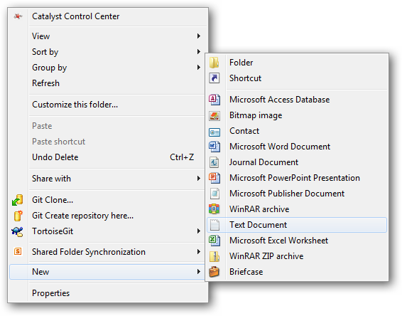

Open the document, now paste the following code into the contents of the document:

cls

@ECHO OFF

title Folder Private

if EXIST "HTG Locker" goto UNLOCK

if NOT EXIST Private goto MDLOCKER

:CONFIRM

echo Are you sure you want to lock the folder(Y/N)

set/p "cho=>"

if %cho%==Y goto LOCK

if %cho%==y goto LOCK

if %cho%==n goto END

if %cho%==N goto END

echo Invalid choice.

goto CONFIRM

:LOCK

ren Private "HTG Locker"

attrib +h +s "HTG Locker"

echo Folder locked

goto End

:UNLOCK

echo Enter password to unlock folder

set/p "pass=>"

if NOT %pass%== PASSWORD_GOES_HERE goto FAIL

attrib -h -s "HTG Locker"

ren "HTG Locker" Private

echo Folder Unlocked successfully

goto End

:FAIL

echo Invalid password

goto end

:MDLOCKER

md Private

echo Private created successfully

goto End

:End

Change the PASSWORD_GOES_HERE text to the password you want to set. Now go ahead and save the file as locker.bat.

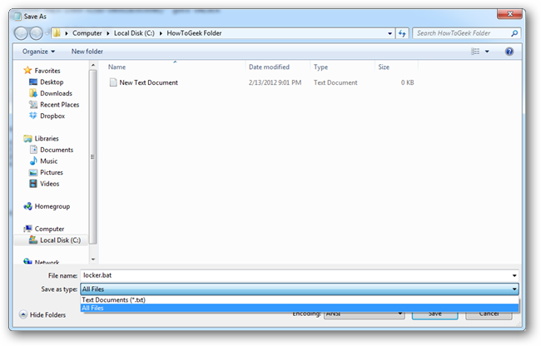

Once the file is saved as a batch file you can delete the original text file.

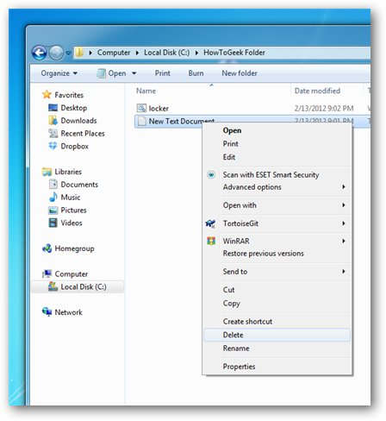

Now run your batch file by double clicking on it–the first time you run it, it will create a folder called Private. This is where you can store all your secret things. When you have finished adding all your stuff to the Private folder, run locker.bat again.

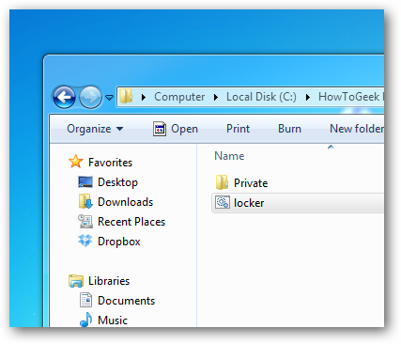

This time you will be asked if you sure that you want to lock the folder, press the “Y” key and hit enter to lock your folder.

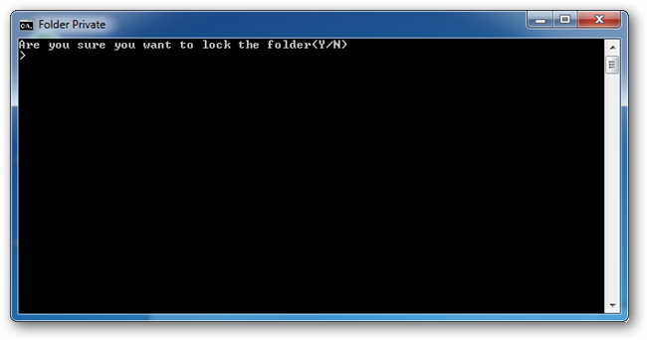

You will see that your Private folder quickly disappears.

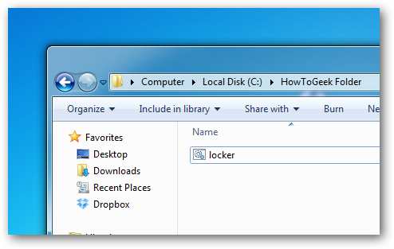

If you run the script yet again, you will prompted for a password.

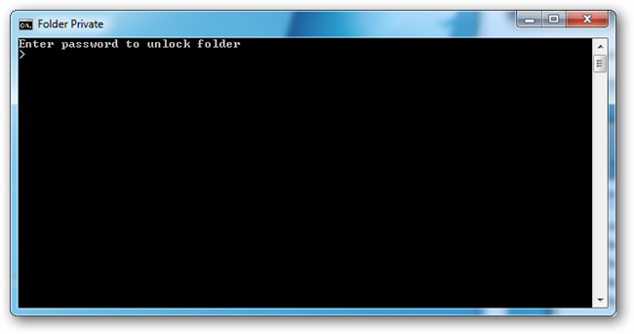

If you enter the same password as you set in the script the Private folder will reappear if you enter the incorrect password the script will just Terminate.

**How to See the Files Again**

Most people don’t know how to show system files, but anybody who has some experience will probably be able to quickly figure it out in the Folder Options. To see the files again, all you have to do is uncheck the boxes for “Show hidden files, folders, and drives” and uncheck the box for “Hide protected operating system files”.

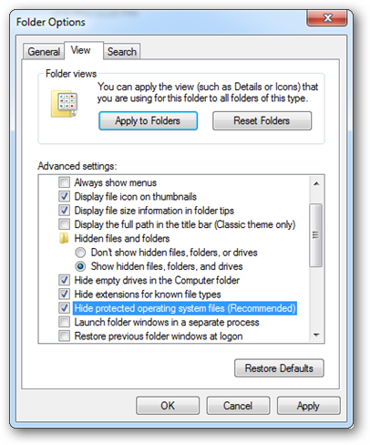

But any ordinary user who unchecks the box will most probably be scared off by the warning message that appears.

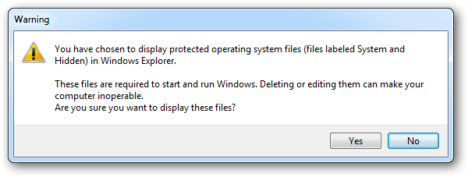

The second way someone could comprise the folder is to open the batch file and read your password. It’s definitely not a really secure way to hide your files, but it is fun.

*Attribution note:* We found this script on dozens of different web sites going back many years. We have no idea who first created the script, so we’ve omitted any sort of attribution link. If you do have proof that you first created the script, contact us and we’ll adjust the article accordingly.

**If You Forget Your Password**

Seems like once a week somebody writes in asking how to figure out the password they set. And the answer is really simple: Right-click on the locker.bat file and choose Edit.

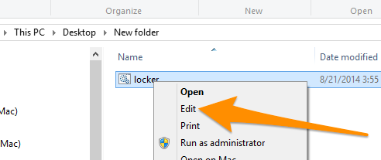

Then you can see the password you set in the file.

[JOIN THE DISCUSSION (12 REPLIES)](http://www.howtogeek.com/105633/how-to-create-a-password-protected-folder-without-any-extra-software/)